1. Добавьте один из суффиксов (-er, -r, -ian, -ist, -man) к словам, чтобы образовалось название профессии. Переведите образовавшиеся слова.

Н-р:    police (полиция) – policeman (полицейский)

1. music (музыка)                                 8. science (наука)
2. journal (журнал)                                9. art (искусство)
3. post (почта)                                      10. sports (спорт)
4. drive (водить машину)                      11. manage (управляться)
5. reception (встреча)                           12. photograph (фотография)
6. electric (электрический)                    13. interpret (переводить)
7. politics (политика)                             14. build (строить)

                                                                15. fire (огонь)

**Упражнение 7.**Сделай правильный выбор. Переведи предложение.  
1. What is the (long, length) of the corridor?  
2. How (long, length) is the street?  
3. He is not (strong, strength) enough to fight with John?  
4. My brother can lift the box because of his (strong, strength).  
5. Nelly’s skirt is too (wide, width).  
6. We can’t get the piano through the door because of its (wide, width).  
7. Is spring a (warmth, warm) season?  
8. We felt the (warm, warmth) of the sun on out faces and hands.  
9. We were surprised at your formal (polite, politeness).  
10. We were not struck by the (white, whiteness) of the snow.

**Упражнение 9.***Образуйте от данных глаголов существительные, используя суффиксы: -er/-or -ment -(a)tion -ion -age -ure -th.*

to construct, to equip, to divide, to inform, to mix, to observe, to move, to break, to direct, to compete, to grow, to press, to radiate, to develop, to protect, to transport, to solve, to recognize , to measure, to fail, to vibrate, to reflect, to treat, to improve, to elect, to educate, to manage, to govern, to achieve, to imagine, to attract

**Упражнение 10.**Вставьте в пробелы абстрактные существительные, образованные от слов, данных в скобках.  
1. Suvorov always showed great courage and … . (wise)  
2. The traveler had to overcome many …. . (difficult)  
3. He sat resting, enjoying the … of the fire. (warm)  
4. He suffered from his own …. . (fool)  
5. This man has extraordinary … . (strong)  
6. The balloon floated at the … of one mile. (high)  
7. She remembered the happy days of her … . (young)  
8. The …  of the canal is seventy kilometres. (long)  
9. Its … is one hundred metres. (wide)  
10. When he came round he felt a strange … and could not stand up (weak).

**Упражнение 11.***Закончите предложения, образуя существительные при помощи суффиксов:****-ee, -ist, — er/or.***

1. A person who plays jazz on the piano is a jazz …..
2. A person who takes professional photographs is a …….
3. The person to whom a letter is addressed is an….
4. A person who employs people is an …
5. A person who works in sails in the sea is a …

**Упражнение 14.***Образуйте существительные от данных прилагательных,  используя суффиксы из таблицы.*[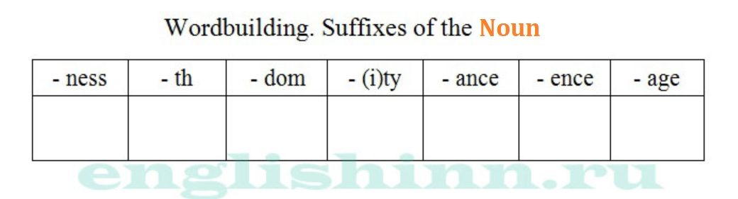](https://englishinn.ru/wp-content/uploads/2016/01/Slovoobrazovanie.-Suffiksy-sushhestvitelnyh.jpg)

able, distant, long, wide, strong, wise, kind, electric, short, white, probable, persistent (упорный), dependent, insistent (настойчивый), indifferent (безразличный), patient, responsible, important, stupid, curious